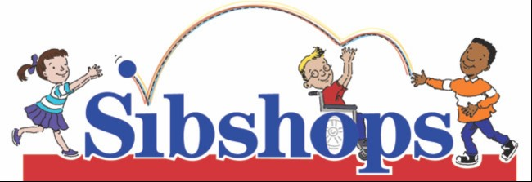
SIBSHOP REGISTRATION FORM
Child’s Name:
Date of birth: Age: Gender:
School: Grade:
Does this child receive any support service (e.g., counseling, speech therapy, special education)?

Parent(s) name(s):
Home address:
Telephone:
Emergency Contact (name and phone number):
Name of sibling(s) with support needs:
Date of birth: Age: Gender:
Nature of disability or illness:

School:
What kind of related special education services (e. g., speech, occupational, or physical therapy, counseling, etc.) does this child receive?
Other siblings
Name Date of birth Age Gender

What are your reasons for enrolling your child in the Sibshop program?

Do you have any concerns about enrolling your child in the Sibshop program?

Do you have any particular topics that you would like addressed during the Sibshop?

Does your child have any food allergies or restrictions?

Is there any other information about your child that is important to know?

Please provide any other information that you feel will make this an enjoyable and educational experience for your child:

I assume all risks and hazards of the conduct of the program. In case of injury, I hereby waive all claims or legal actions, financial, or otherwise against Pony Bird, their elected officials and employees, the organizers, sponsors, supervisors, or volunteers connected with the program. In absence of a signature, payment of fees and participation in the program shall constitute acceptance of the conditions set forth in the release. I grant full permission to use any photographs, videos, recordings, or any other recording of this program for any purpose.

Signature of parent or guardian Date

Please return this form and the registration fee in the form of a check made out to Pony Bird and mail to:

Pony Bird
Family Support
3655 Baptist Park Rd
Festus, MO 63028

If you would like your child to be considered for a scholarship, please call Pony Bird Family Support at 636-282-1414. Donations to the Sibshop Scholarship fund are gratefully accepted!

